

United States International University

MIS 6020: Application Domains of IT

Application Software Exercise

Spreadsheet Exercise: Improving Supply Chain Management

You run a company that manufactures aircraft components. You have many competitors who are trying to offer lower prices and better service to customers and you are trying to determine if you can benefit from better supply chain management. Use the spreadsheet file provided that contains a list of all of the items that your firm has ordered from its suppliers over the past three months. The fields on the spreadsheet file include vendor name, vendor identification number, the purchaser's order number, item identification number and item description (for each item ordered from the vendor), the cost per item, number of units of the item ordered, the total cost of each order, the vendor's accounts payable terms, promised shipping date, promised transit time, and actual arrival date for each order.

Prepare a recommendation of how you can use the data in this spreadsheet database to improve your supply chain management. You may wish to look at ways to identify preferred suppliers or other ways of improving the movement and production of your products. Some criteria you might consider include: the supplier's track record for on-time deliveries, suppliers offering the best accounts payable terms, and suppliers offering lower pricing when the same item can be provided by multiple suppliers. Use your spreadsheet software to prepare reports and, if appropriate, graphs to support your recommendations.

Required:
- Identify preferred suppliers based on the raw data provided.
- Identify the best accounts payable terms.
- Identify the best price for same item provided by multiple suppliers.

Steps to solve 1: Identify preferred suppliers based on the raw data provided.

Below is the raw data. It has to be raw data, previously unprocessed, typically a list of some sort.

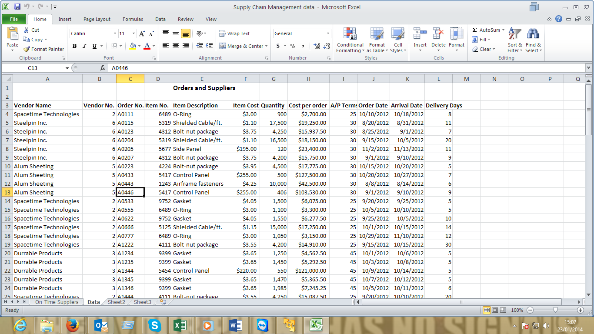

- Select all the coulumns and rows of the data sheet.
- Select the Insert tab on the file menu.
- Select INSERT tab and choose PIVOT Table.

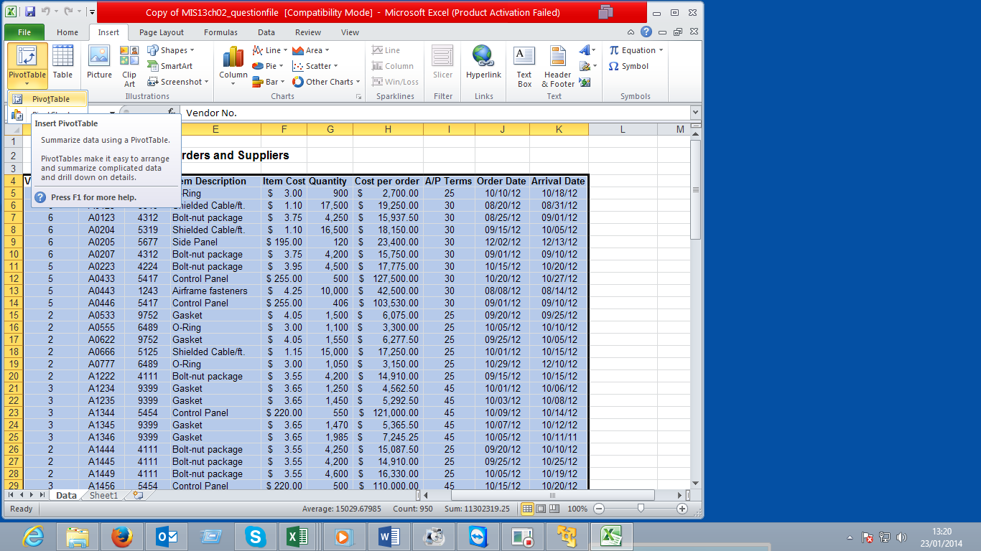

The following dialog appears. Note that we could select a list in any other region of any other worksheet, or even some external data source, such as an Access database table, or even a MS-SQL Server database table. We also need to select whether we want our new PivotTable to be created on a new worksheet, or on an existing one.
- Leave the defaults and click OK
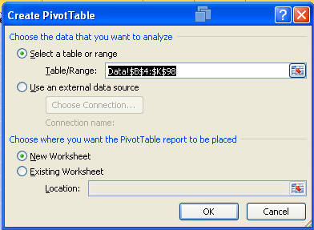

The new worksheet is created for us, and a blank PivotTable is created on that worksheet:
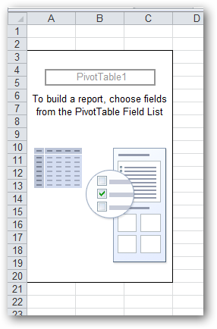
- On the pivot table list drag the Vendor name, Vendor NO to the Row Lables. Drag the Delivery Days field to the Values
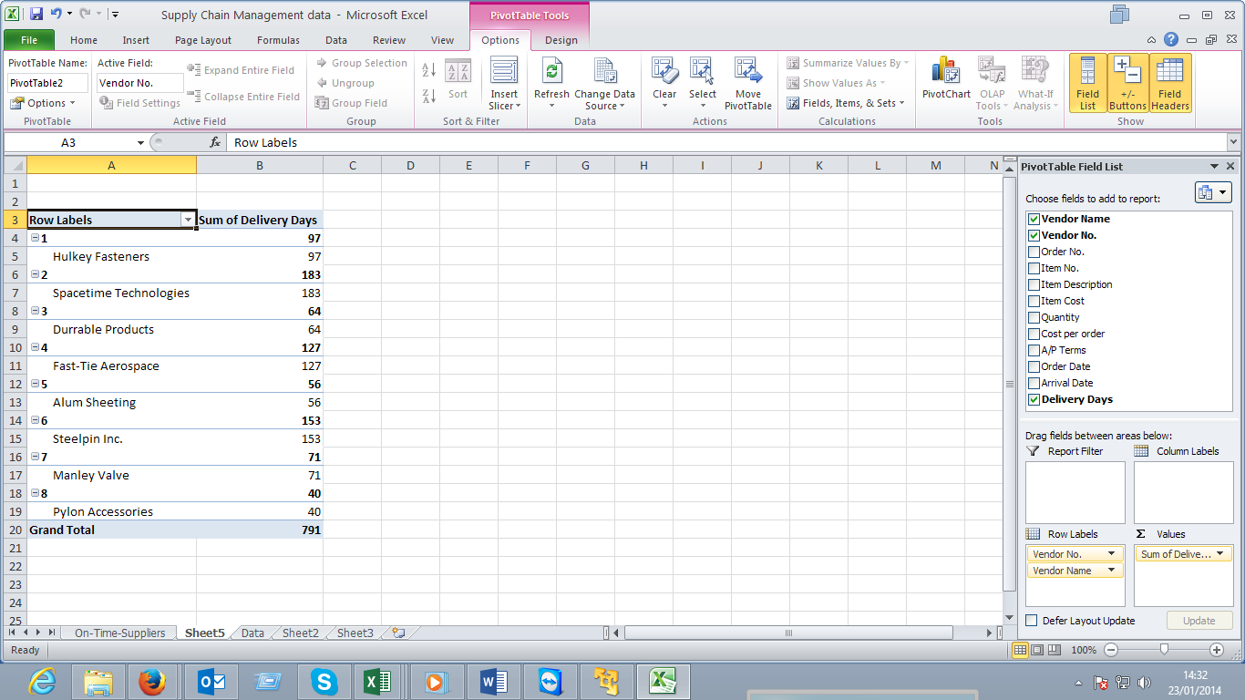

Since the Grand total row is not included in our query, it should be deleted from the pivot table.
- Select the Design option on the PivotTable Tools and click on the drop down arrow and select the Off for rows and columns
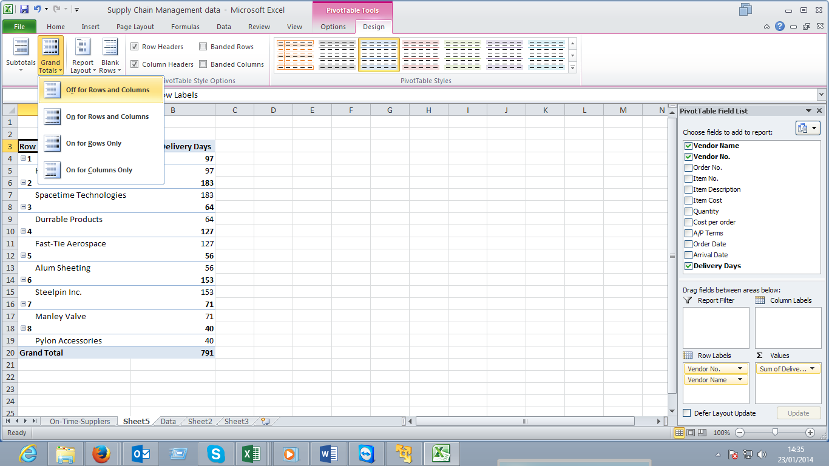
- At the values where the Delivery Time field was dragged, click on the Sum of Delivery and select the vlaue field settings.
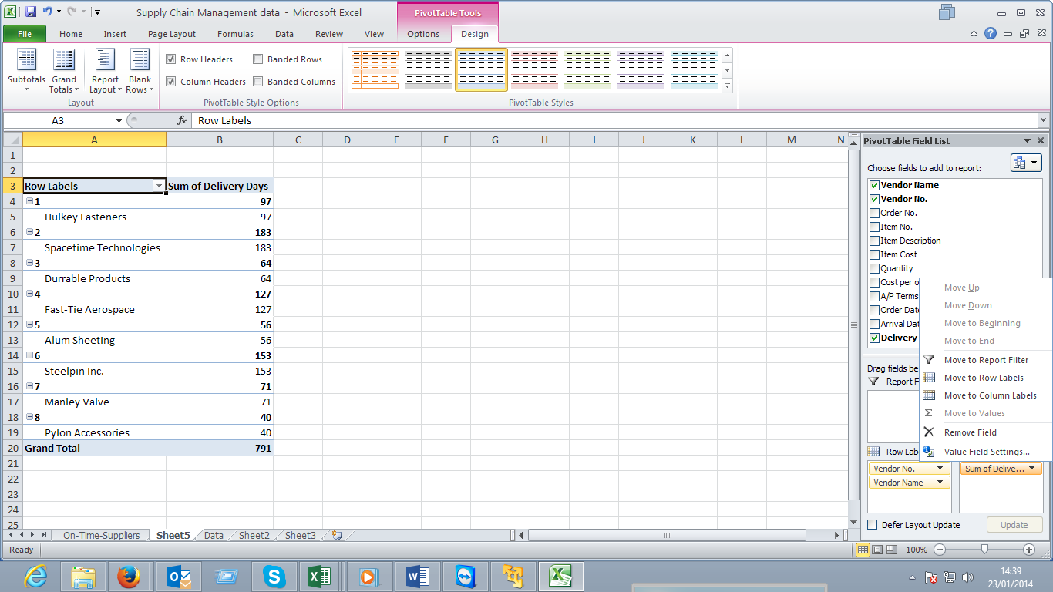

The dialog appears. Select the average as the type of calculation

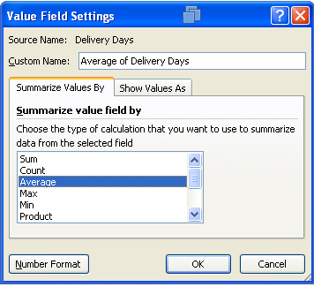
- Click on the Number Format button to edit the decimal places.
- Change it from 2 to 0 click ok and close the dialog.
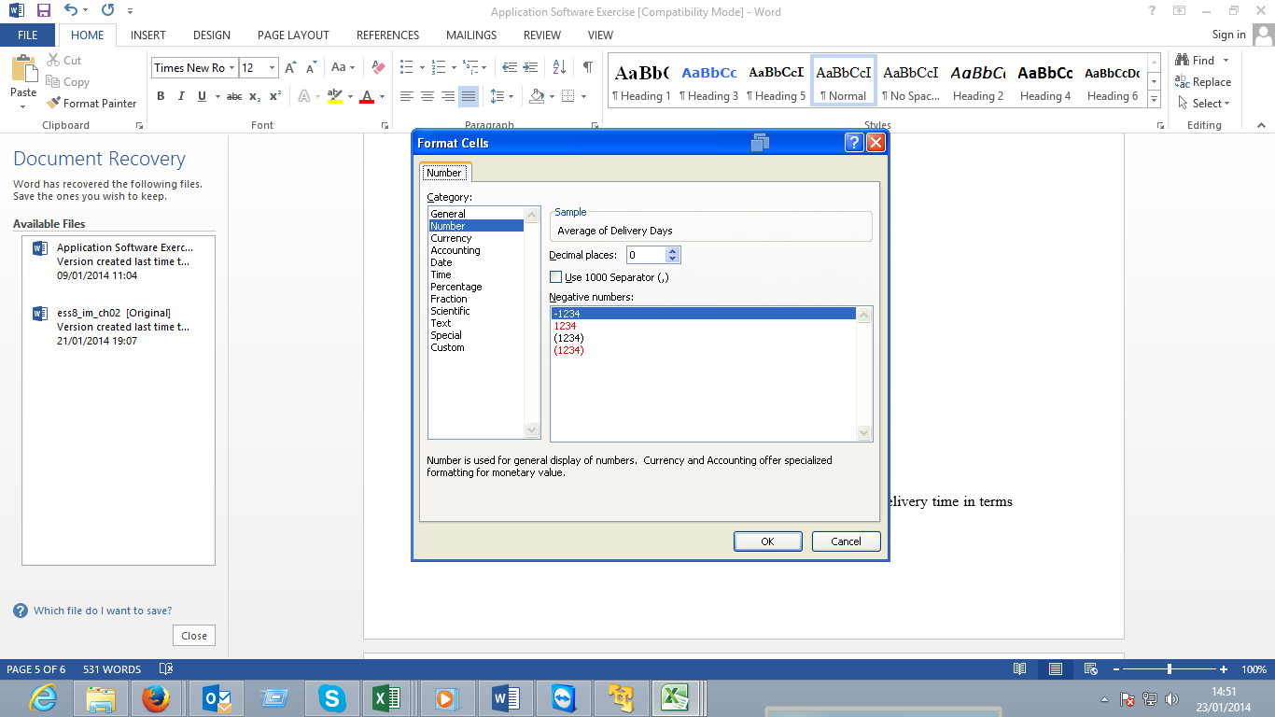

The table is now complete with the vendor name and the average delivery time in terms of days.

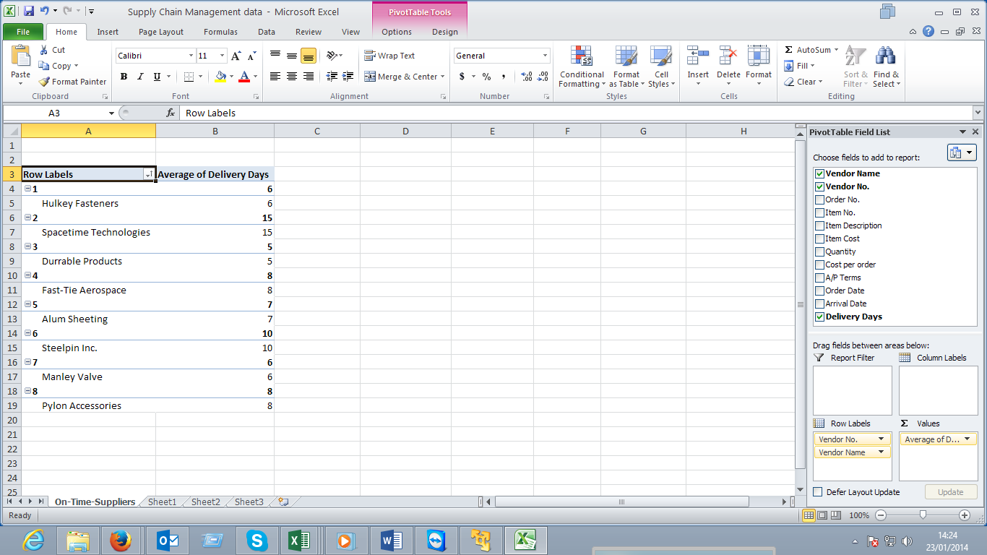
We need to change the design to reflect a report format. Click on design on the PivotTable tools
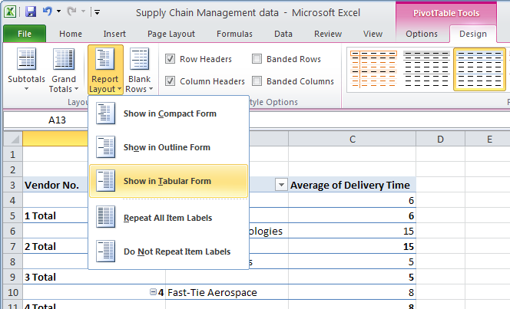
The next step is to remove the duplicates from the table.
- On the Design tab select the sub totals drop down arrow and select Do Not Show Subtotals.

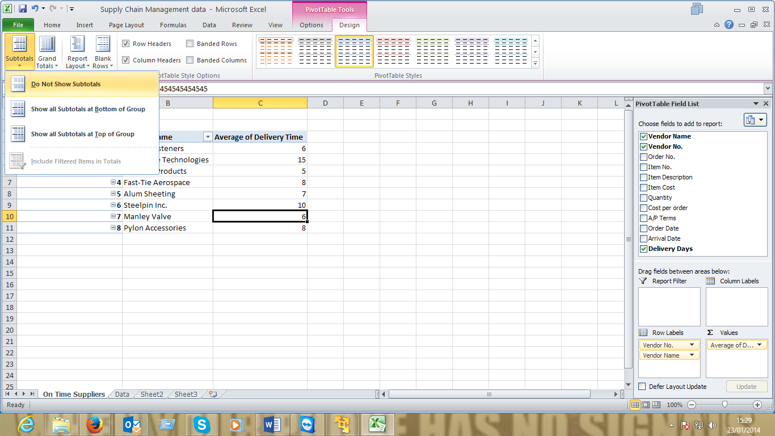

The formating is complete the report should look as below
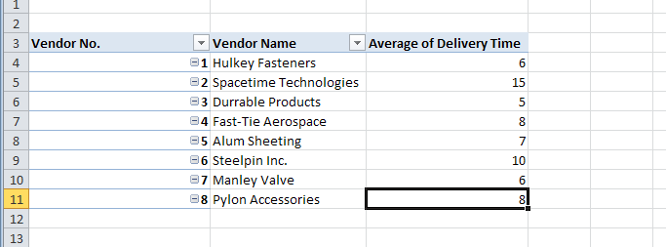

The table summary shows the average time each vendor takes to deliver items.
For requirements 2 and 3 use the same data to create the pivot tables for each.

